Chapter 4, Problem 76.

Solve Prob. 4.34 using PSpice.

Chapter 4, Problem 34.

Find the Thevenin equivalent at terminals a-b of the circuit in Fig. 4.98.

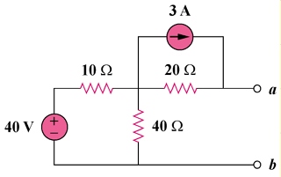

Figure 4.98
For Prob. 4.76.

